**3 | Specific Requirements**

**3.1 External Interfaces Requirements**

**3.1.1 User Interfaces**

In this section the UI of the web application is presented, there are two types of user interfaces, one for “companies” and the other one for “students”. Companies have the possibility to post internship offers. Students have the possibility to upload their CVs, search and apply for internships offered by the companies. Each type needs to provide the correct credentials to have access to the platform. In case any loss of credentials, “Forgot Password” mechanism would be needed.

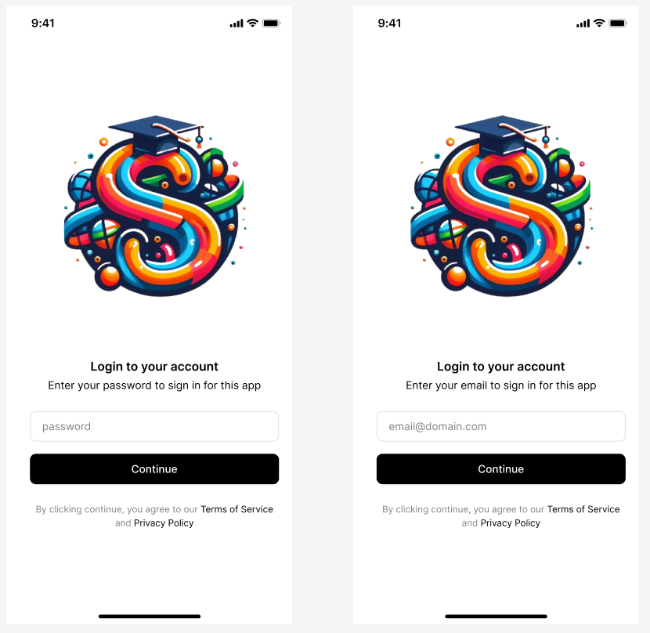

**3.1 User Login**

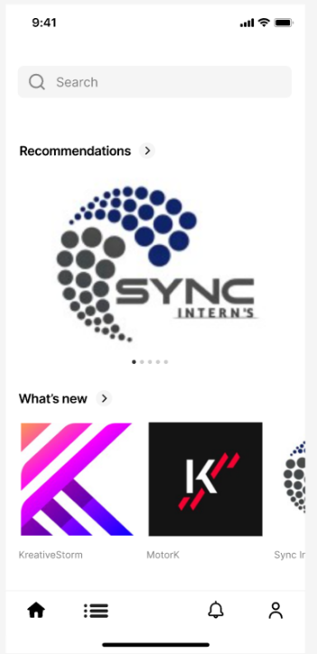

**3.2 Student Interface**

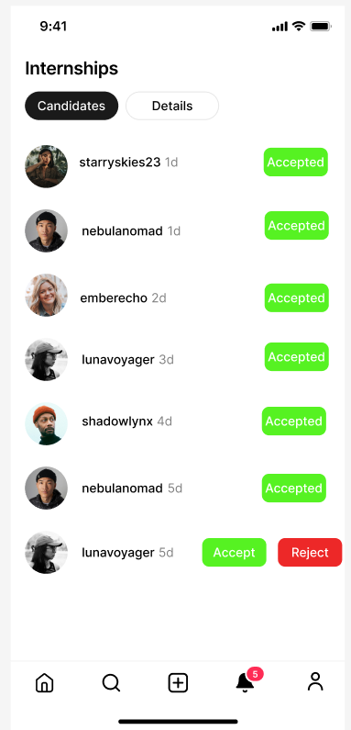

**3.3 Accept / Reject Candidates**

**3.1.2 Hardware Interfaces**

As a web app, the platform doesn’t require any specific hardware interface rather than a computer and a device with a web browser.

**3.1.3 Software Interfaces**

The system needs some software interfaces to be able to do the functionality:

* Static analysis tool API: To analyze feedbacks and information collected to get statistics, in order to be able to provide suggestions to companies about project description and students about CVs.

**3.1.4 Communication Interfaces**

Users are going to need a good internet connection in order to have access to the platform:

* Companies need to upload internship offers.
* Students need to upload their CVs, search and apply for offers.
* Communicate with each other during the selection process.

The platform must use HTTPS to guarantee working properly and safety.

**3.2 Functional Requirements**

**3.2.1 Sign up and Log in**

[R1] The system allows “Companies” to register by providing their information (company name, company description, certifications, …).

[R2] The system allows “Students” to register by providing personal information (full name, academic email, password, phone number, date of birth, nationality, address, …).

[R3] The system allows “Students” to upload their CVs.

[R4] The system allows registered “Companies/ Students” to log in.

**3.2.2 Publishing internship offers**

[R5] Registered companies can post an internship offer by providing information needed (title, description, requirements, type, duration, location, number of students needed, key words).

**3.2.3 Search and Apply for internship**

[R6] The system allows “Students” to search for internship offers by writing a meaningful search word (job title, company name, …) and specifying if its paid or not.

[R7] The system allows registered “Students” to apply for an internship offer by providing all information needed from his profile(name, phone number, email, CV, …), and by filling up any additional requirement provided by the company.

**3.2.4 Recommendations**

[R8] The system regularly sends recommendations to the students based on information provided during the registration process(age, address, …), information in the CV(experience, skills, projects, …), and search keywords they use.

[R9] The system regularly sends recommendations about potential candidates based on the information, requirements, and key words provided in the offer post.

**3.2.5 Acceptance and Interview scheduling**

[R10] Students can accept or reject an internship offer provided by a company.

[R11] Companies can accept or reject candidates based on the company needs provided in the offer post.

[R12] Students must be notified about their request status(accepted, rejected), based on company selection.

[R13] After the acceptance process, the system sends a questionnaire to students and companies, so they will be able to schedule an interview appointment (possible dates, possible times, online/offline), to proceed with selection process.

**3.2.6 View and Monitor status of internship**

[R14] Each registered student has a list of all internships he is accepted in with a report of status, rates, projects, and feedbacks.

[R15] The system should have a list of all internships with all its information (company name, company profile, offer details, number of students, start date, end date, status, students rates).

[R16] Companies, and Universities should have access to view the status of each internship based on the information provided from the reports.

**3.3 Use Case Diagram**

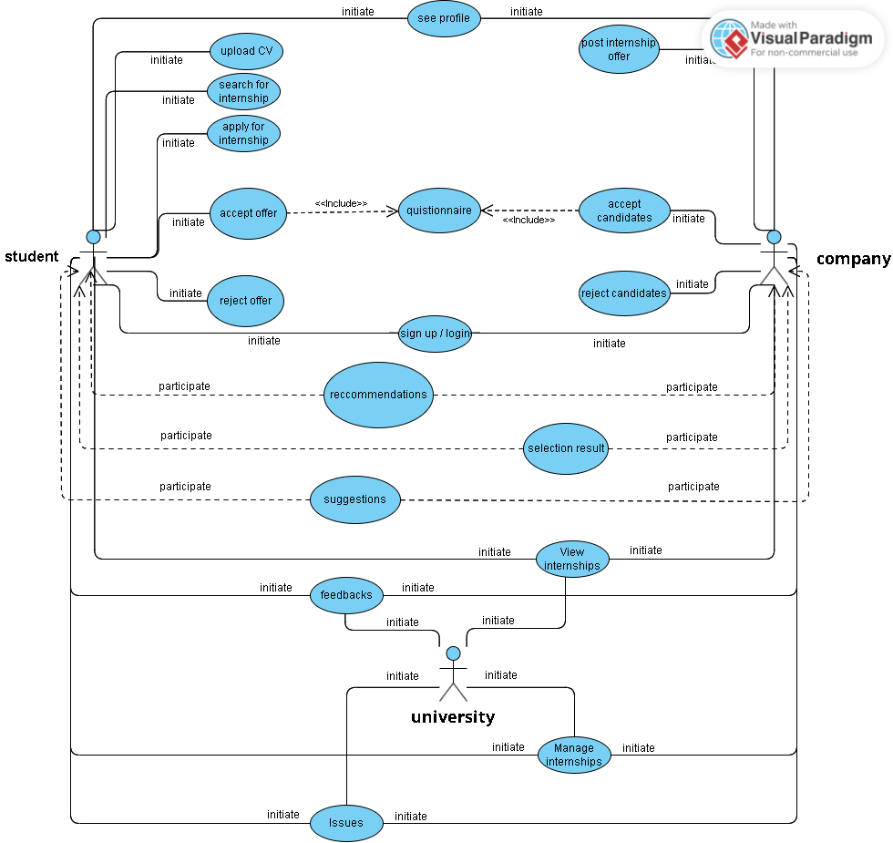

**[UC1] User Sign Up**

| Actors | * Student / Company * System |
| --- | --- |
| Entry Condition | Student/Company enters the platform. |
| Event Flow | 1. Student/Company presses Sign up button. 2. The system shows a form to be filled. 3. Student/Company fills the form by adding their credentials. 4. Student/Company presses “Register” to complete the registration . 5. The system redirects to the profile page. |
| Exit Condition | Student/Company successfully registered to the platform. |
| Exception | c. Student/Company is already registered. |

**[UC2] User Login**

| Actors | * Student / Company * System |
| --- | --- |
| Entry Condition | Student/Company enters the platform. |
| Event Flow | 1. Student/Company presses “Sign in” button. 2. The system shows a form to be filled. 3. Student/Company fills the form by adding their credentials. 4. Student/Company presses “Sign in” to complete the login. 5. The system redirects to the profile page. |
| Exit Condition | Student/Company successfully accessed the platform. |
| Exception | c. Credentials are incorrect, the system returns to the entry condition. |

**[UC3] Post Internship Offer**

| Actors | * Company * System |
| --- | --- |
| Entry Condition | Company pressed the “Post” button. |
| Event Flow | 1. Company presses Post button. 2. The system shows a form to be filled with all offer details. 3. Company fills all form fields. 4. Company presses “Post” to submit the form. |
| Exit Condition | Company successfully posted the internship offer. |
| Exception | c. Company didn’t fill all the fields in the form or filled with invalid information. |

**[UC4] Search for Internship**

| Actors | * Student * System |
| --- | --- |
| Entry Condition | Student enters the platform. |
| Event Flow | 1. Student writes meaningful search words in the search bar. 2. Student presses on the “Search” button. 3. The system shows results based on information provided. |
| Exit Condition | System shows the search results. |
| Exception | Student is not registered in the system. |

**[UC5] Apply for Internship**

| Actors | * Student * System |
| --- | --- |
| Entry Condition | Student presses “Apply” button. |
| Event Flow | 1. System shows a form with necessary field of information to be filled. 2. System automatically fills some fields based on information presented in the student profile and CV. 3. Student fills any other unfilled necessary field. 4. Student presses the “Submit” button to complete the application. |
| Exit Condition | System successfully sends the application and redirects the student to the searching page. |
| Exception | c. Student didn’t fill all the necessary fields in the form or filled with invalid information. |

**[UC6] Accept an Internship Offer**

| Actors | * Student * System |
| --- | --- |
| Entry Condition | Student presses the “Offer” button. |
| Event Flow | 1. Student presses on the “Internship” button to enter the internships section. 2. Student presses on the “Offer” button inside the internships section to view the received offers. 3. System shows a list of received offers if any. 4. Student selects an offer. 5. System redirects student to the offer details page. 6. Student presses “Accept” button. 7. System saves the choice and sends an acceptance notification to the company sent the offer. 8. System updates the offer status and removes the rejected offers from the received offers list. |
| Exit Condition | System successfully saves the choice, notifies the company, and redirects the student to the offers section page. |
| Exception | g. System didn’t manage to save the choice and send the notification successfully, so the system notifies the student about the unsuccessful process and redirects him to the offers section page. |

**[UC7] Reject an Internship Offer**

| Actors | * Student * System |
| --- | --- |
| Entry Condition | Student presses the “Offer” button. |
| Event Flow | 1. Student presses on the “Internship” button to enter the internships section. 2. Student presses on the “Offer” button inside the internships section to view the received offers. 3. System shows a list of received offers if any. 4. Student selects an offer. 5. System redirects student to the offer details page. 6. Student presses “Reject” button. 7. System saves the choice and sends a rejection notification to the company sent the offer. 8. System updates the offer status and removes the rejected offers from the received offers list. |
| Exit Condition | System successfully saves the choice, notifies the company, and redirects the student to the offers section page. |
| Exception | g. System didn’t manage to save the choice and send the notification successfully, so the system notifies the student about the unsuccessful process and redirects him to the offers section page. |

**[UC8] Accept Candidates**

| Actors | * Company * System |
| --- | --- |
| Entry Condition | Company presses the “Candidates” button. |
| Event Flow | 1. Company presses on the “Internship” button to enter the internships section. 2. System shows a list of all internship offers the company posted if any. 3. Company selects an internship offer from the list. 4. System redirects company to the internship page. 5. Company presses on the “Candidates” button to enter the candidates section. 6. System shows a list of all candidates applied for the internship if any. 7. Company presses “Accept” button for each candidate to be accepted. 8. System saves the choices and sends an acceptance notification to the accepted candidates(students). 9. System updates the status of each candidate and removes the rejected candidates from the candidates list. |
| Exit Condition | System successfully saves the choice, notifies the accepted candidates(students), and redirects the company to same page after the update. |
| Exception | h. System didn’t manage to save the choices and send the notifications successfully, so the system notifies the company about the unsuccessful process and redirects to the internship section page. |

**[UC9] Reject Candidates**

| Actors | * Company * System |
| --- | --- |
| Entry Condition | Company presses the “Candidates” button. |
| Event Flow | 1. Company presses on the “Internship” button to enter the internships section. 2. System shows a list of all internship offers the company posted if any. 3. Company selects an internship offer from the list. 4. System redirects company to the internship page. 5. Company presses on the “Candidates” button to enter the candidates section. 6. System shows a list of all candidates applied for the internship if any. 7. Company presses “Reject” button for each candidate to be rejected. 8. System saves the choices and sends a rejection notification to the rejected candidates(students). 9. System updates the status of candidates removes the rejected ones from the candidates list. |
| Exit Condition | System successfully saves the choice, notifies the rejected candidates(students), and redirects the company to same page after the removal of the rejected candidates. |
| Exception | h. System didn’t manage to save the choices and send the notifications successfully, so the system notifies the company about the unsuccessful process and redirects to the internship section page. |

**[UC10] Send Selection Results**

| Actors | * Company * System |
| --- | --- |
| Entry Condition | Company presses the “Candidates” button. |
| Event Flow | 1. Company presses on the “Internship” button to enter the internships section after the end of the interviews. 2. System shows a list of all internship offers the company posted if any. 3. Company selects an internship offer from the list. 4. System redirects company to the internship page. 5. Company presses on the “Candidates” button to enter the candidates section. 6. System shows a list of all candidates applied for the internship if any. 7. Company presses “Reject” button for each candidate to be rejected. 8. System saves the choices and sends a notification(rejection, acceptance) to the candidates(students). 9. System updates the status of each candidate and removes the rejected candidates from the candidates list. |
| Exit Condition | System successfully saves the choice, notifies the candidates(students), and redirects the company to same page after the update. |
| Exception | h. System didn’t manage to save the choices and send the notifications successfully, so the system notifies the company about the unsuccessful process and redirects to the internship section page. |

**3.4 Sequence Diagrams**

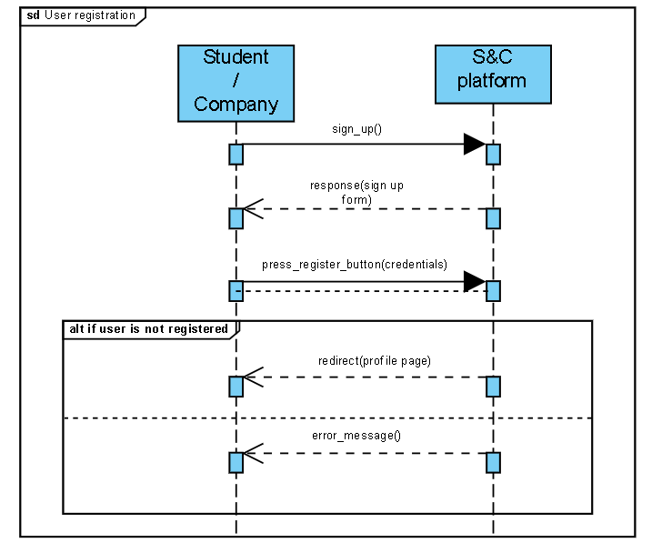

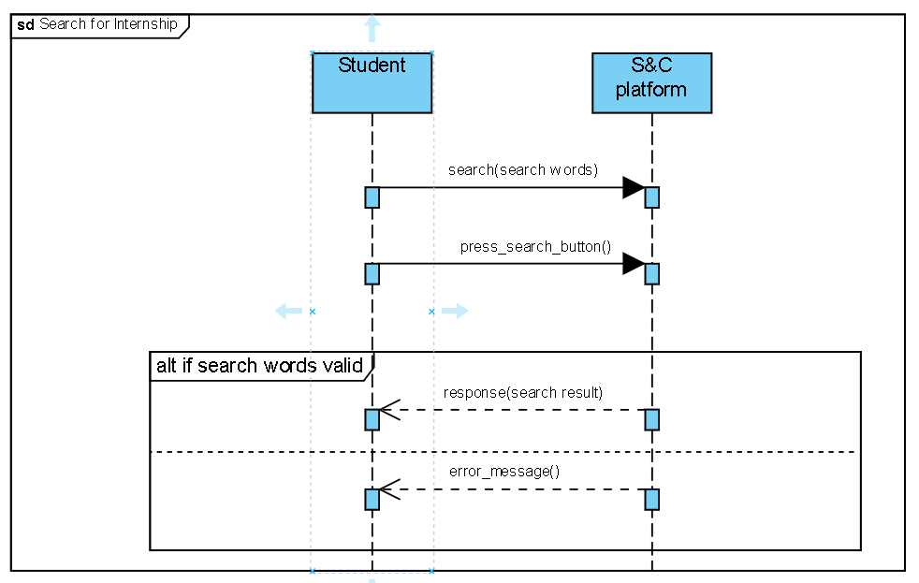

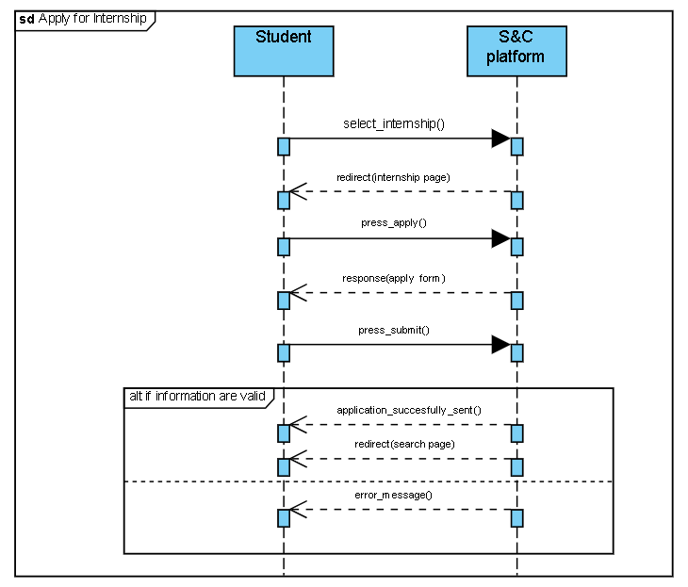

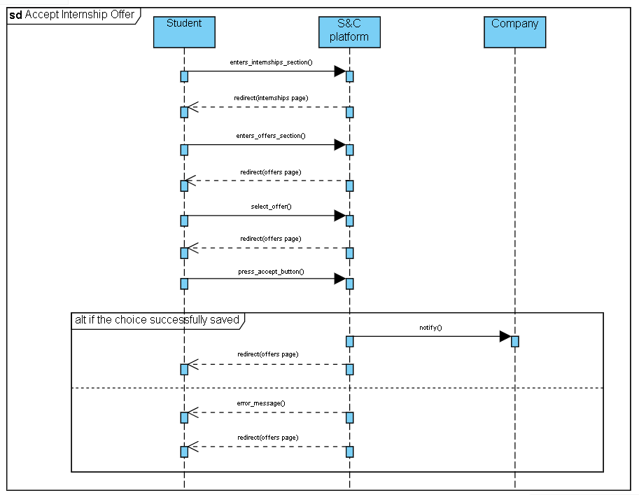

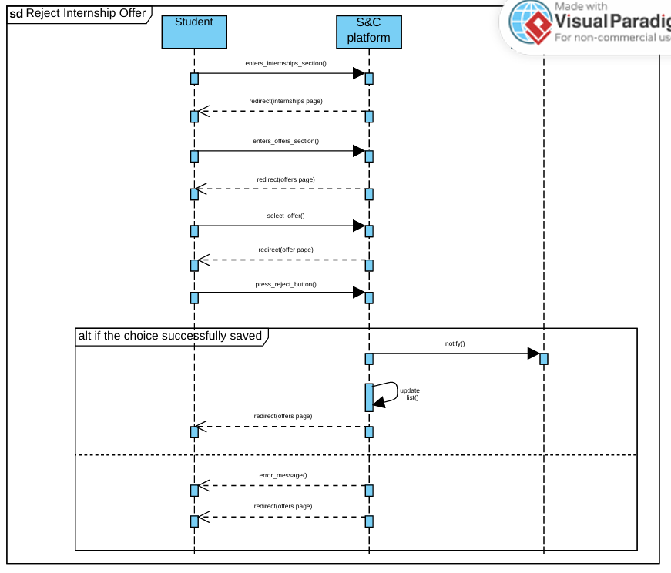

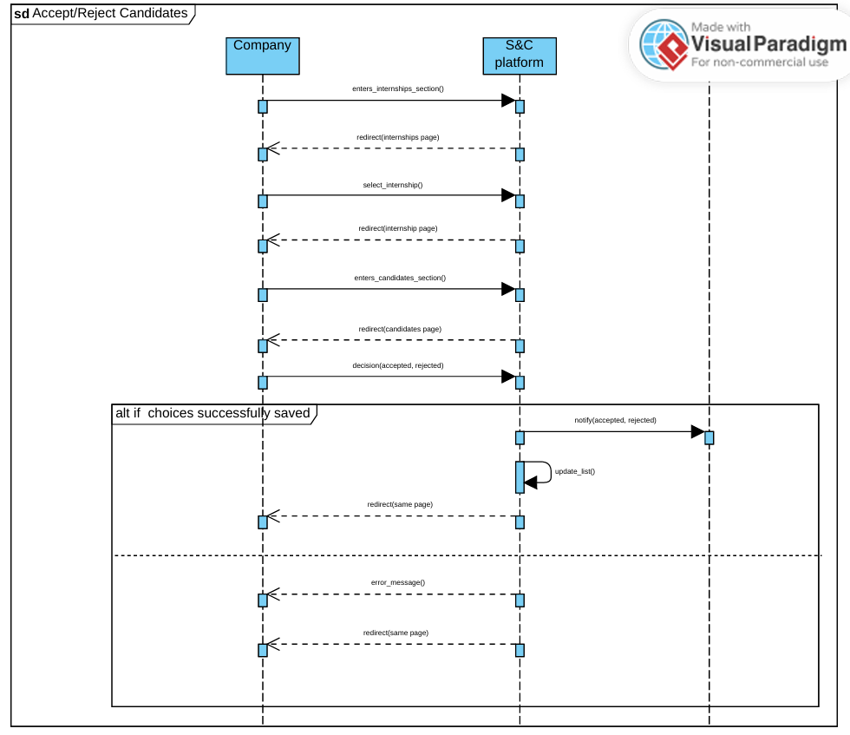

**3.5 Design Constraints**

**3.5.1 Hardware Limitations**

Here is presented a summary of the hardware features that user should have to use the platform properly:

• The user must have a device with good internet connection (should be compatible with at least one of these standards 3G, 4G, 5G, IEEE 802.11 and IEEE 802.3). Both for the wired and wireless communications it must be connected to a device able to guarantee an internet connection such as a modem or an access point and so on.

• The user can have a device with normal hardware features such as (smartphone, laptop, tablet).

**3.6 Software System Attributes**

Here we will explain some software attributes that the system should provide.

**3.6.1 Reliability**

The system must be reliable because it will have to run continuously for a long period of time. To ensure this feature the platform must have some sort of replication and consistency policy to avoid system crash. Moreover, as best practice, it is important to have offline backups of the system for recovering information after data loss.

**3.6.2 Availability**

This isthe most important attribute the system must provide. The system should be available most of the time. Some replication policies must be implemented, it must be prepared for a possibly large number of submissions when a new offer is posted.

**3.6.3 Security**

The system will store the user’s personal data so the security aspect must be carefully considered.

* Passwords stored in the central database must be encrypted.
* Stored data must be protected with all possible security measures to avoid internal and external attacks.
* The platform must ensure integrity, consistency and confidentiality by using appropriate cyber-risk avoidance policies.

**3.6.4 Maintainability**

The system must guarantee a good level of maintainability. The code must be well documented. A testing routine must be provided, and it has to cover at least 75% of the code.

**3.6.5 Portability**

The system is a web application so it must be compatible with different web browsers such as (Firefox, Google Chrome, …), and devices such as(smartphones, computers, …).